Tema pentru acasa 8

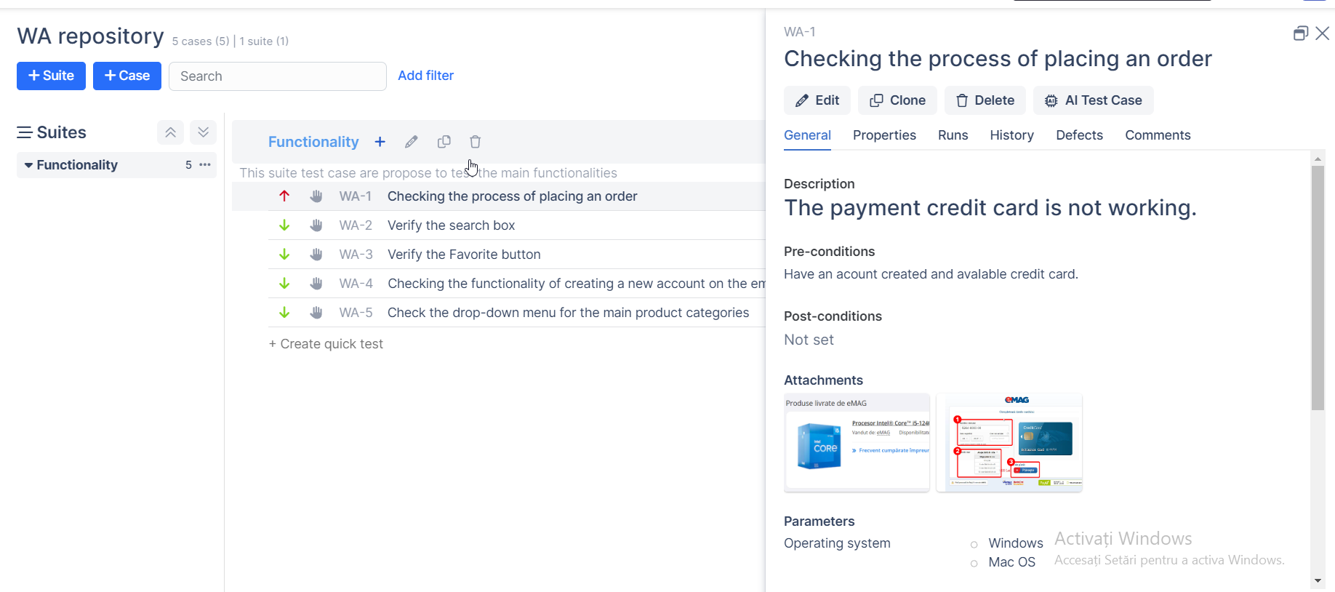

Primul Test case

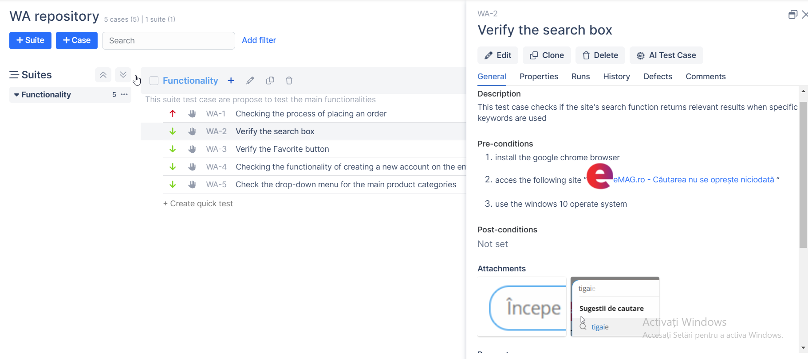

Al doilea test case

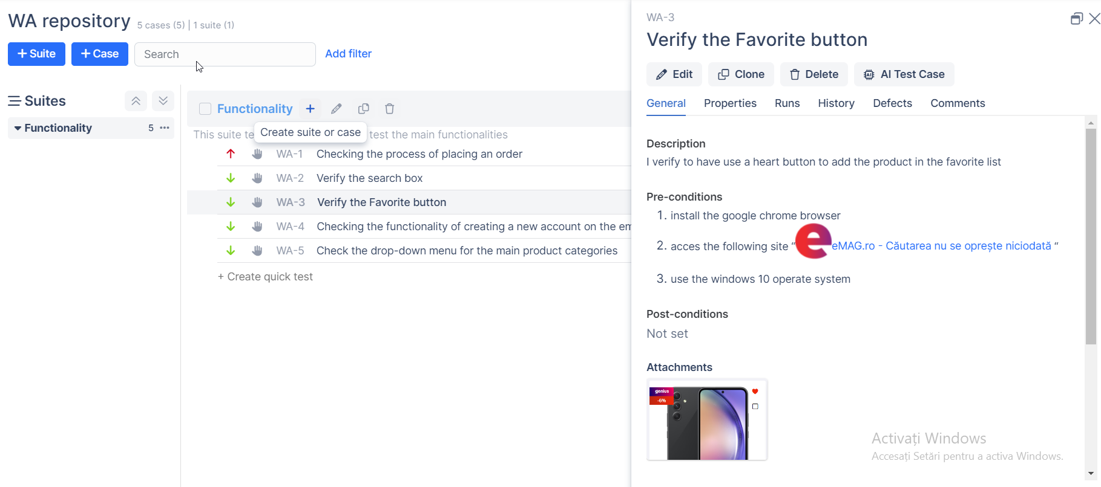

Al treilea test case

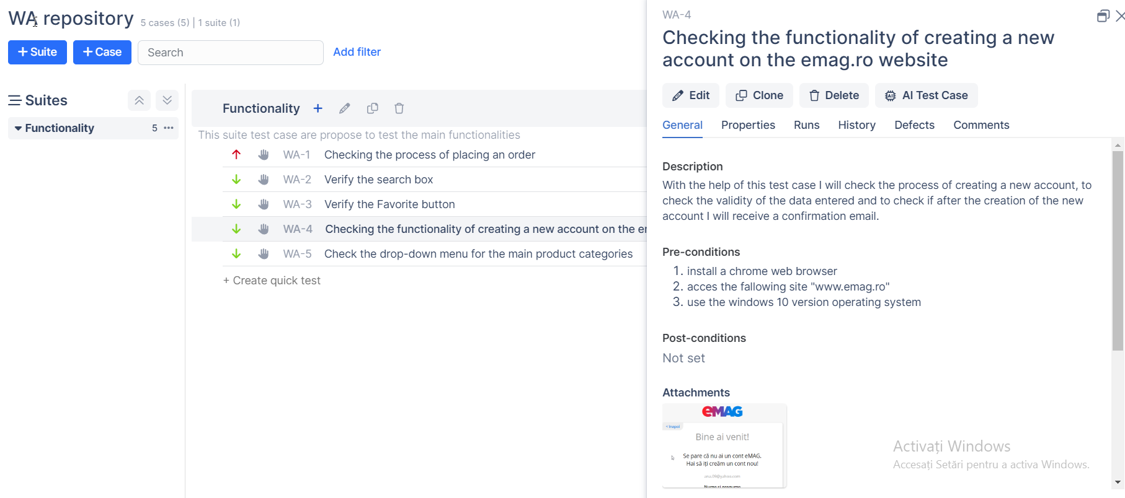

Al patrulea test case

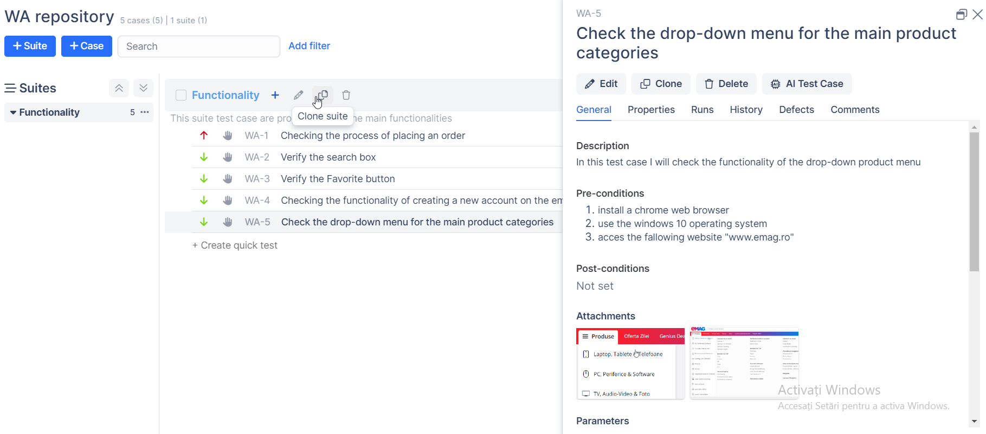

Al cincilea test case

[Video cu tema din Qase](https://drive.google.com/file/d/1cMy-Jssk3X4lTgrFeJqVurTCt82kxuB3/view?usp=sharing)

[Video cu tema din Jira](https://drive.google.com/file/d/174txjCNxtW4muLf3BApKFUn3NiDfmITj/view?usp=sharing)

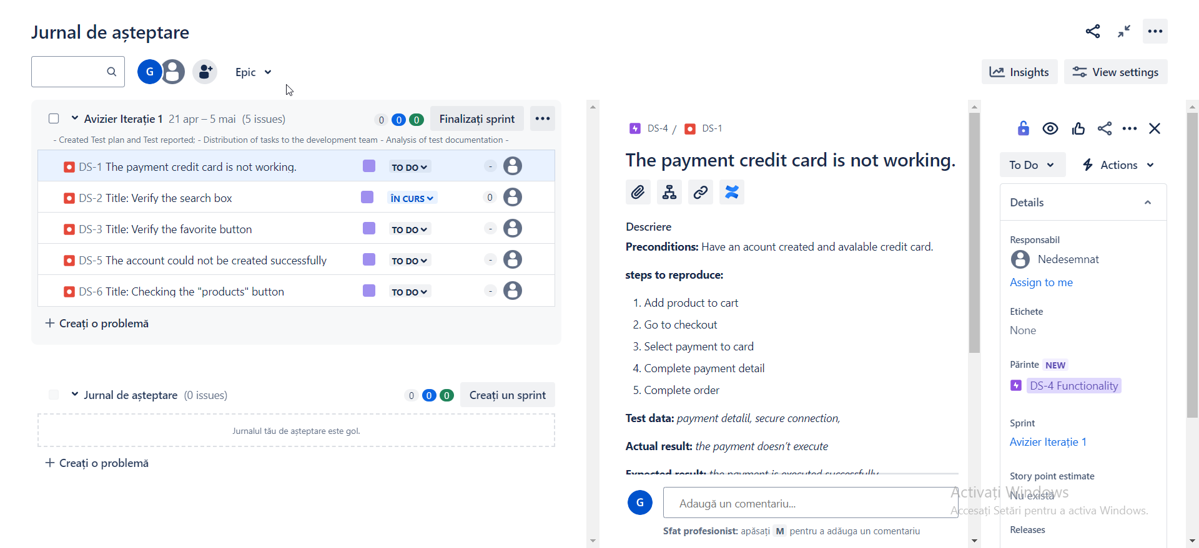

Primul Bug Report

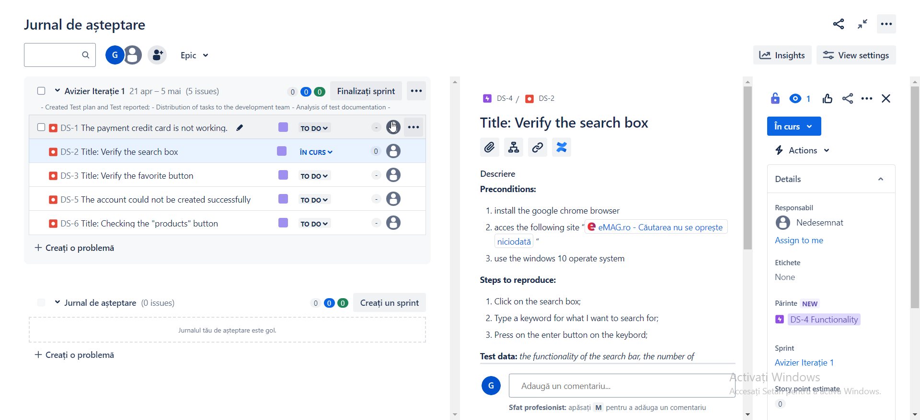

Al doilea Bug Report

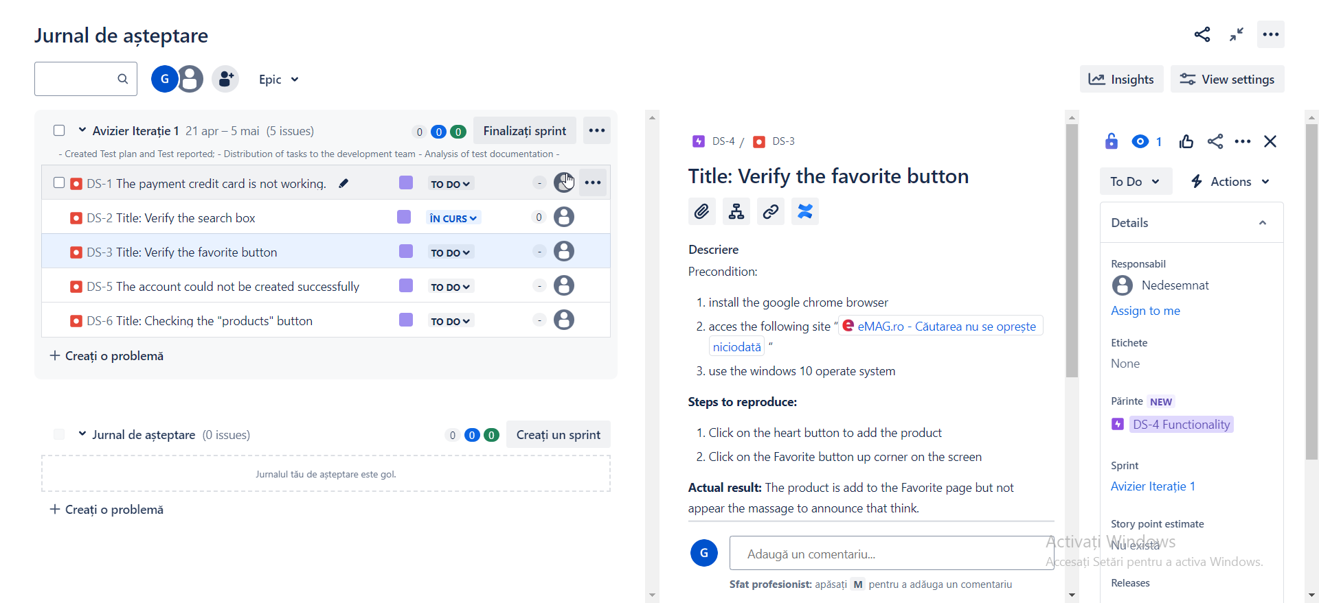

Al treilea Bug Report

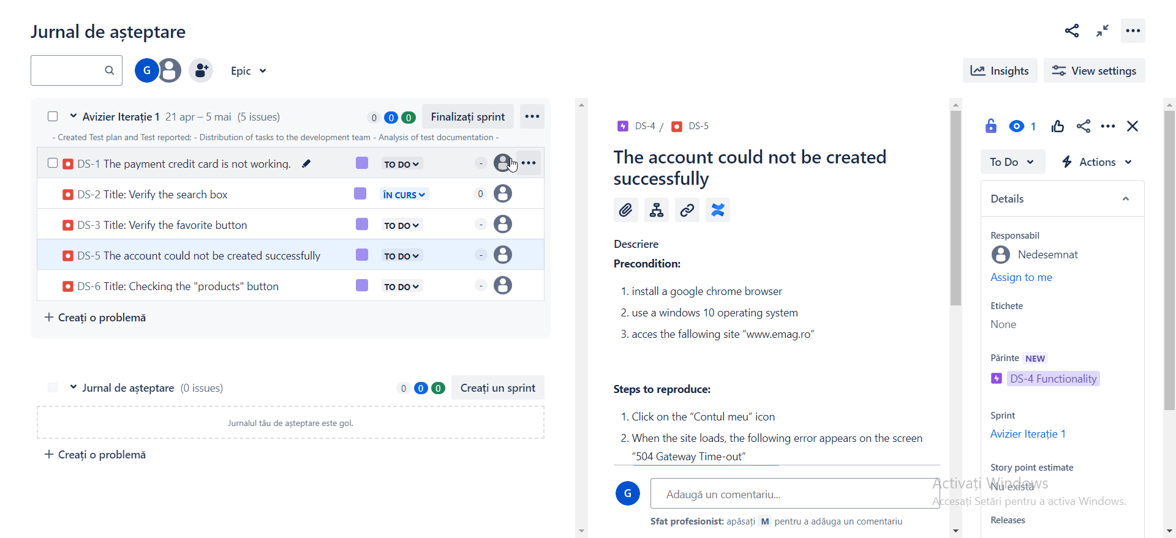

Al patrulea Bug Report

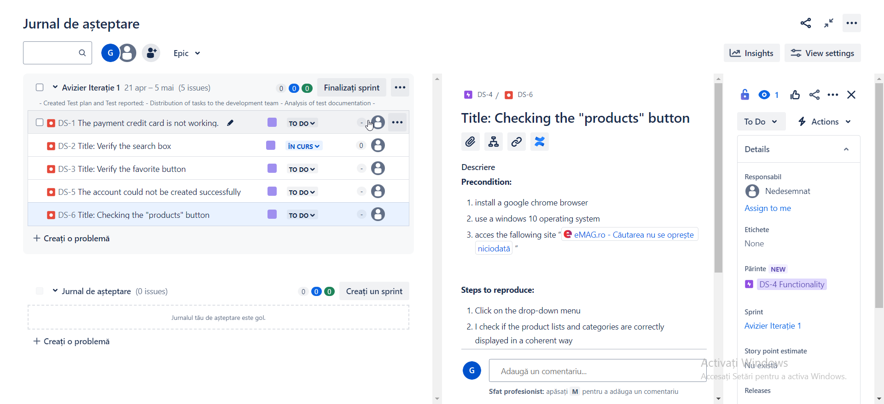

Al cincilea Bug Report